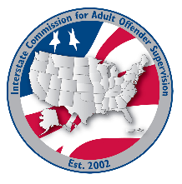
executive committee

MEETING AGENDA
Interstate Commission for Adult Offender Supervision
Date: | November 18, 2026
Time: | 12:00 pm ET
Location: | Join Zoom Meeting

call to order

approval of agenda and minutes

October 12, 2026

Committee and Region reports
  - Finance Committee – Megan Milner
  - Compliance Committee – Dale Crook
  - DCA Liaison Committee – Alyssa Miller
  - Information Technology Committee – Steve Turner
  - Rules Committee –Tracy Hudrlik
  - Training, Education & Public Relations Committee – Jeremy Vukich
  - ABM Workgroup – Joselyn López
  - East Region – David Cady
  - Midwest Region – Amy Vorachek
  - South Region – John Mosley
  - West Region – Taryn Link

Executive Director Report
  - Ashley Lippert

Victim Advocate Report
  - Sandy Hunt

Old/NEW business

V. Adjourn

