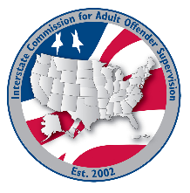
Training committee MEETING AGENDA
Interstate Commission for Adult Offender Supervision
Date: | November 17, 2026
Time: | 2:00 pm ET
Location: | Join Zoom Meeting

Agenda items

call to order

Approval of Agenda & Minutes
- August 11, 2026

Discussion
- Committee overview
- INSITE Update
- VRT Update
- VRT Training
- DCA Leadership program
- Conference Trainings
- Learning Management System Update

Old/NEW business
- 2026 ABM Survey Results

Adjourn

