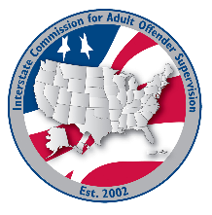
ABM Workgroup

MEETING AGENDA
Interstate Commission for Adult Offender Supervision
Date: | November 11, 2026
Time: | 2:30 PM ET
Location: | Join Zoom Meeting

call to order

Discussion
- 2026 ABM Evaluation
- 2027 ABM Need Assessment

Old/NEW business

Adjourn

