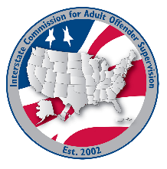
DCA Liaison committee

MEETING AGENDA
Interstate Commission for Adult Offender Supervision
Date: | August 25, 2026
Time: | 1:00 pm ET
Location: | Join Zoom Meeting

call to order

approval of agenda & minutes

May 27, 2026

Discussion
- Prep for the ABM
  - What’s left?
  - Are we ready?
- Input on INSITE training environment options

Old/New business

Adjourn

