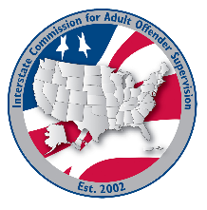
Training committee MEETING AGENDA
Interstate Commission for Adult Offender Supervision
Date: | August 11, 2026
Time: | 2:00 pm ET
Location: | Join Zoom Meeting

Agenda items

call to order

Approval of Agenda & Minutes
- June 18, 2026

Discussion
- ABM Agenda
  - ABM Session Prep

- INSITE Training Updates

Old/NEW business
- Committee Expo at the ABM

Adjourn

