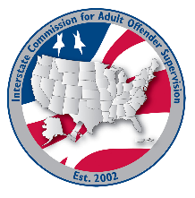
finance committee

MEETING AGENDA
Interstate Commission for Adult Offender Supervision
Date: | June 24, 2026
Time: | 11:00 AM ET
Location: | Join Zoom Meeting

Agenda items

call to order

approval of agenda and MInutes

February 25, 2026

Discussion
- Executive Committee Update:
  - Budget
  - Travel Policy-Reimbursement for Travel Days
- INSITE cost changes
- Committee Expo at the ABM

Old/New business

Adjourn

