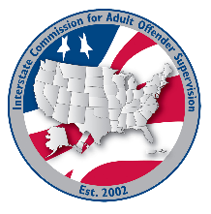
executive committee

MEETING AGENDA
Interstate Commission for Adult Offender Supervision
Date: | June 24, 2026
Time: | 12 pm ET
Location: | Join Zoom Meeting

call to order

approval of agenda and minutes

May 20, 2026

Committee and Region reports
  - Compliance Committee – Dale Crook
  - DCA Liaison Committee – Alyssa Miller
  - Finance Committee – Gary Roberge
  - Information Technology Committee – Chris Moore
  - Rules Committee –Tracy Hudrlik
  - Training, Education & Public Relations Committee – Katrina Ransom
  - ABM Workgroup – Joselyn López
  - East Region – David Cady
  - Midwest Region – Amy Vorachek
  - South Region – Steve Turner
  - West Region – Taryn Link

Executive Director Report
  - Ashley Lippert

Victim Advocate Report
  - Sandy Hunt

Old/NEW business
  - RNR Workgroup Update – Amy Vorachek

VIII. Adjourn

