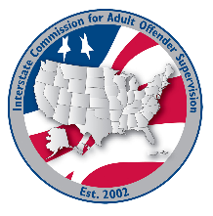
RULES committee

MEETING AGENDA
Interstate Commission for Adult Offender Supervision
Date: | June 16, 2026
Time: | 11:00 PM ET
Location: | Join Zoom Meeting

call to order

approval of agenda & Minutes

June 8, 2026

Discussion
- Review rule proposal comments

OLD/new business
- Virtual Public Hearing
- ABM Committee Expo Table
- Review Mandatory Transfer Terminology
- Set effective date for rule proposals

Adjourn

