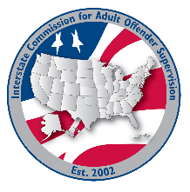
Training committee MEETING AGENDA
Interstate Commission for Adult Offender Supervision
Date: | June 18, 2026
Time: | 2:00 pm ET
Location: | Join Zoom Meeting

Agenda items

call to order

Approval of Agenda & Minutes
- April 21, 2026 & February 25, 2026

Discussion
- Ex-Officio Meeting
- ABM Agenda
- INSITE training updates
- DCA Leadership Program

Old/NEW business

Adjourn

