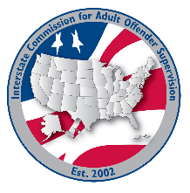
COMPLIANCE committee

MEETING AGENDA
Interstate Commission for Adult Offender Supervision
Date: | June 2, 2026
Time: | 1:00 PM ET
Zoom Link: | Join Zoom Meeting

call to order

approval of agenda

Approval of minutes

April 22, 2026

Discussion
- Review Rules Chapter 6 to identify any necessary compliance-related updates

Old/New business

Adjourn

