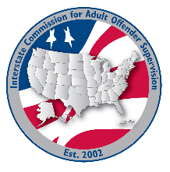
Technology committee

MEETING AGENDA
Interstate Commission for Adult Offender Supervision
Date: | May 28, 2028
Time: | 11 AM ET
Location: | Join Zoom Meeting

Agenda items

call to order

approval of agenda & Minutes

December 17, 2025

Discussion
- Revised INSITE Privacy Policy for approval
  - Recommendation to archive AP 04-2009
- Revised AP 2018-02 Enhancements for approval
  - New Enhancement Request Form
  - Technology Committee Scoring Rubric

Old/NEW business

Adjourn

