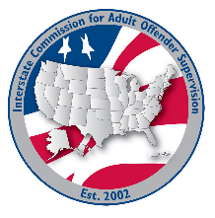
SOUTH Region

MEETING AGENDA
Interstate Commission for Adult Offender Supervision
Date: | May 11, 2026
Time: | 11:00 am ET
Location: | Join Zoom Meeting

call to order

roll call

approval of agenda and minutes

January 13, 2026

Discussion
- Commission Updates:
  - New Commission Website & User Accounts
  - INSITE Launch Update
  - RNR Pilot Outcomes Results
  - 2026 Rule Proposals
    - Comments Period – April 23- June 5
    - Rules Committee Townhall @ 2PM ET on June 1, 2026
  - Updated Administrative Policies
    - AP 01-2026 - Code of Conduct & Compliance
  - 2026 ABM Agenda
  - Commission Awards Nominations – July 1, 2026:
    - Executive Director Award
    - Victims Advocate Award
    - Spirit of the Compact Award
- DCA Region Chair Update

Old/New business

Adjourn

